**A Comprehensive Anti-Theft Vehicle Protection Framework Using Embedded Electronics and Python**

**Kandimalla Mallikarjuna Rao**

Assistant Professor Department of ECE

KKR & KSR Institute of Technology and Sciences

Guntur, Andra Pradesh, India

malli.siva2000@gmail.com

**Loya Ravi Teja**

B. Tech Student Department of ECE

KKR & KSR Institute of Technology and Sciences

Guntur, Andra Pradesh, India

[21jr1a04g7@gmail.com](mailto:21jr1a04g7@gmail.com)

**Tatanaboina Johny**

B. Tech Student Department of ECE

KKR & KSR Institute of Technology and Sciences

Guntur, Andra Pradesh, India

[21jr1a04i2@gmail.com](mailto:21jr1a04i2@gmail.com)

**Pinapala Sai Pavan**

B. Tech Student Department of ECE

KKR & KSR Institute of Technology and Sciences

Guntur, Andra Pradesh, India

[21jr1a04f9@gmail.com](mailto:21jr1a04f9@gmail.com)

**Vennapusa Chinna Lingareddy**

B. Tech Student Department of ECE

KKR & KSR Institute of Technology and Sciences

Guntur, Andra Pradesh, India

21jr1a04j0@gmail.com

**Abstract**

Vehicle theft remains a significant concern, necessitating the development of advanced security systems that provide real-time monitoring and effective deterrence. This project, "A Comprehensive Anti-Theft Vehicle Protection Framework Using Embedded Electronics and Python," presents a robust solution integrating biometric authentication, sensor-based detection, image capture, and remote communication to ensure comprehensive vehicle safety. The system is built around an ESP32 microcontroller that coordinates with various components, including a fingerprint sensor for authorized access, a vibration sensor for detecting unauthorized tampering, and a camera module to capture images of potential intruders, which are stored and emailed using Wi-Fi. A display module (OLED or LCD) provides real-time feedback on system status, while a mosquito module emits ultrasonic waves to deter intruders. Upon verified access, a DC motor enables vehicle operation, and in the event of a breach, GSM and GPS modules send SMS alerts with the vehicle’s live location. The GSM module also supports remote control, allowing the user to activate or deactivate the motor via SMS. Additionally, a buzzer and display work in tandem to notify nearby individuals and the owner of a security threat. This integrated system leverages embedded electronics and IoT technologies to deliver an intelligent, multi-layered defense against vehicle theft.

**Keywords:** Vehicle Security, Embedded Systems, Biometric Authentication, IoT-Based Monitoring, Theft Detection

**1.Introduction**

In today’s world, the threat of vehicle theft continues to be a major concern for individuals and communities alike. Despite advancements in automotive technology, many conventional security systems still fall short in preventing unauthorized access or quickly responding to theft attempts. As criminals adopt more sophisticated methods, it becomes essential to develop smarter, more integrated security solutions. This project, "A Comprehensive Anti-Theft Vehicle Protection Framework Using Embedded Electronics and Python," proposes a modern and effective approach to vehicle security by leveraging the power of embedded systems and IoT technologies.

At the heart of the system is the ESP32 microcontroller, which coordinates multiple components such as biometric fingerprint sensors, vibration detectors, a camera module, and GPS/GSM units. These elements work together to form a layered defense system. Authorized users can access the vehicle through fingerprint verification, while any unauthorized activity—such as forced entry or suspicious movement—triggers immediate actions like alarms, ultrasonic deterrence, and image capture. The captured images are sent to the owner via email using Wi-Fi, while SMS alerts with real-time location data are sent through the GSM and GPS modules. The system also supports remote control of the vehicle's ignition through SMS commands.

This framework not only enhances the physical security of the vehicle but also empowers the owner with real-time updates and control, creating a smart, responsive, and user-centric approach to vehicle protection. By combining embedded hardware with Python programming, the solution is both technically robust and practically effective in addressing the growing challenges of vehicle theft

**2.Background of the Study**

With the advancement of technology, vehicle theft has become more sophisticated, rendering traditional security systems like locks and alarms increasingly ineffective. As a result, there is a growing demand for intelligent, real-time security frameworks that can detect, respond to, and prevent unauthorized access. This project, *"A Comprehensive Anti-Theft Vehicle Protection Framework Using Embedded Electronics and Python,"* addresses that demand by leveraging modern embedded systems and IoT technologies.

Designed by Pinapala Sai Pavan, Loya Ravi Teja, Vennapusa Chinna Lingareddy, and Tatanaboina Johny, under the guidance of K. Mallikarjuna Rao, the system uses an ESP32 microcontroller to coordinate fingerprint-based authentication, vibration sensing, GPS tracking, image capturing, and GSM-based communication. These modules work together, managed via Python programming, to provide a multi-layered defense system that not only alerts the vehicle owner in real-time but also allows remote control and visual identification of intruders.

By combining hardware efficiency with software flexibility, this project demonstrates how embedded electronics can be used to create a smarter, more reliable solution for vehicle theft prevention offering both safety and convenience in today’s connected world.

**3.Technologies Used**

**3.1. ESP32 WROOM-32 Module**

Acts as the central controller of the system. It processes input from all sensors and modules, handles wireless communication, and executes decision-making logic. It is preferred for its dual-core processor, low power consumption, and inbuilt Wi-Fi/Bluetooth capabilities. Its built-in support for IoT applications makes it ideal for smart vehicle security systems.

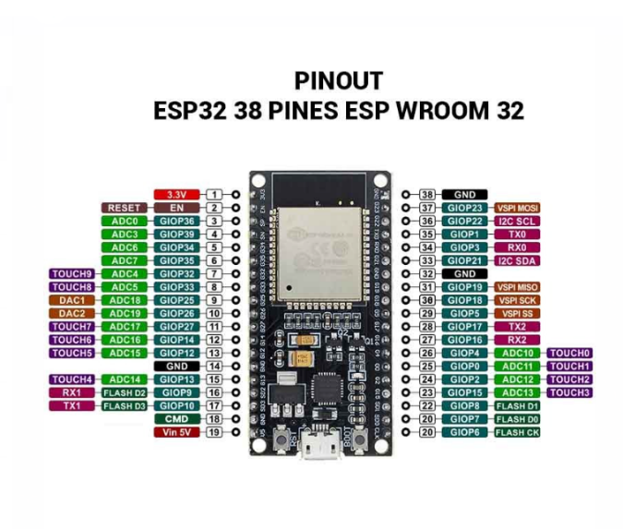

**Fig.1:** ESP 32 WIFI Wroom-32 Module

**3.2. R307S Fingerprint Sensor Module**

Ensures secure biometric access to the vehicle. It stores fingerprint data and compares real-time input to grant or deny access. With support for up to 1000 fingerprint templates and fast recognition speeds, it enhances security by making it nearly impossible for unauthorized users to start the vehicle.

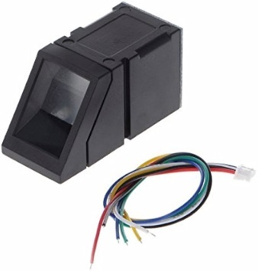

**Fig.2:** R307S Fingerprint Sensor Module

**3.3. SW-420 Vibration Sensor Module**

Monitors external vibrations or shocks on the vehicle, which could indicate a break-in attempt or unauthorized movement. Upon detection, it triggers alerts and countermeasures. It is highly sensitive and capable of detecting even minor disturbances.

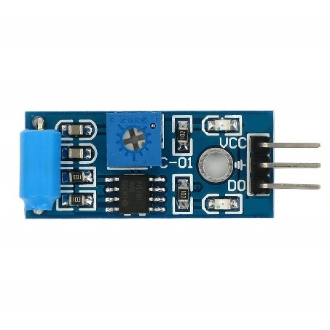

**Fig.3:** SW-420 Vibration Sensor Module

**3.4. Laptop Camera Module**

Utilized as the primary image-capturing device for intruder identification. When suspicious activity is detected, it captures photos using the laptop’s integrated webcam and sends them via email. This ensures evidence collection without requiring additional camera hardware.

**3.5. I2C LCD Display Module**

Provides a visual interface for the user to monitor system status, access results, and alerts in real-time. It uses I2C communication for simplified wiring and faster updates, offering clear feedback even in low-light conditions.

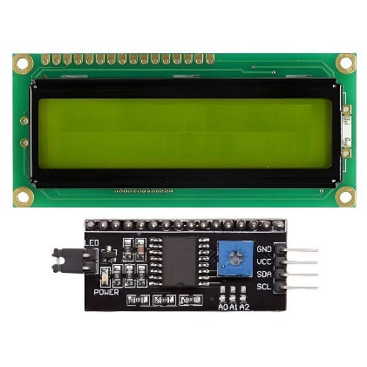

**Fig.4:** I2C LCD Display Module

**3.6. Mosquito Module (Electric Shock Emitter)**

Generates high-voltage output upon detecting intrusion to deter physical tampering. This non-lethal defense mechanism serves as an active deterrent for unauthorized persons and is activated only when unauthorized access is confirmed.



**Fig.5:** Mosquito Module (Electric Shock Emitter)

**3.7. DC Motor**

Acts as a representation of the vehicle ignition system. It only activates when proper authentication is confirmed, simulating starting or stopping the vehicle. It demonstrates the system’s control over engine functions.

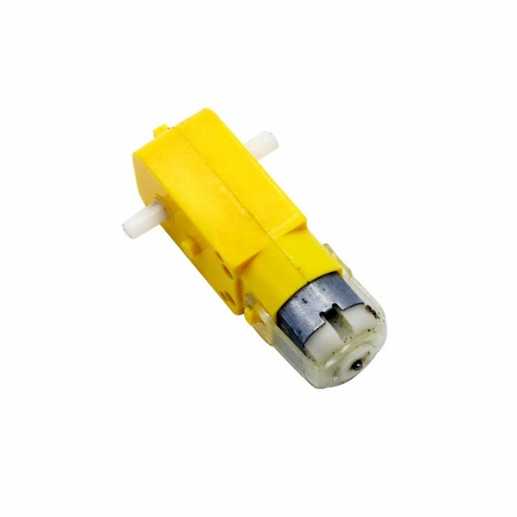

**Fig.6:** DC Motor

**3.8. GY-NEO6MV2 NEO-6M GPS Module**

Continuously monitors the vehicle’s position and provides GPS coordinates. These are used for real-time tracking and are sent to the owner via SMS. The module is known for its high accuracy and fast satellite locking capabilities.

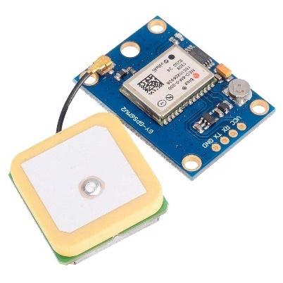

**Fig.7:** GY-NEO6MV2 NEO-6M GPS Module

**3.9. SIM800C GPRS GSM Module**

Handles all SMS-based communication. Sends alerts to the owner with location data and allows remote control of the system, such as turning the ignition on/off via specific SMS commands. It operates reliably even in low signal conditions.



**Fig.8:** SIM800C GPRS GSM Module

**3.10. Buzzer**

Acts as a local alarm to notify people nearby in case of a security breach. It works in tandem with other alerts to enhance situational awareness and deter unauthorized users.



**Fig.9:** Buzzer

**4.Working of the System**

**4.1. Overview**

The anti-theft vehicle protection system integrates biometric authentication, vibration detection, GPS tracking, and GSM-based alerting into a unified embedded framework. The ESP32 microcontroller manages all modules to detect unauthorized access, respond appropriately, and ensure real-time communication with the vehicle owner. Using Python for additional functionalities like image capture and email notification, the system combines embedded hardware and software for a smart vehicle security solution.

**4.2. Normal Operation Mode**

At system startup, the fingerprint sensor is activated and ready to accept input from both authorized and unauthorized users. The I2C LCD display shows the initial status of the fingerprint scanner and updates to reflect the authentication result. If a registered fingerprint is detected, the system activates the DC motor, simulating vehicle ignition, and confirms access through the LCD.

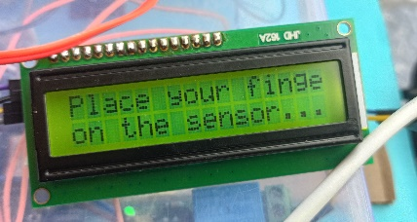

**Fig.10:** Initail Mode of the Execution of the project

**4.3. Unauthorized Access Detection**

If an unregistered fingerprint is detected, the system takes immediate action. The mosquito module is triggered to emit a deterrent high-voltage pulse, and the buzzer sounds an alarm to alert nearby individuals. Simultaneously, the I2C display notifies the user of unauthorized access. The laptop camera, controlled via Python, captures an image of the intruder and sends it to the owner's registered email address using SMTP protocol.

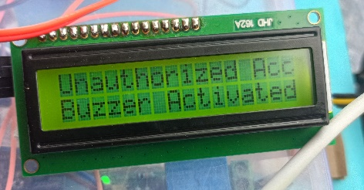  
**Fig.11:** Unauthorized Access Detected

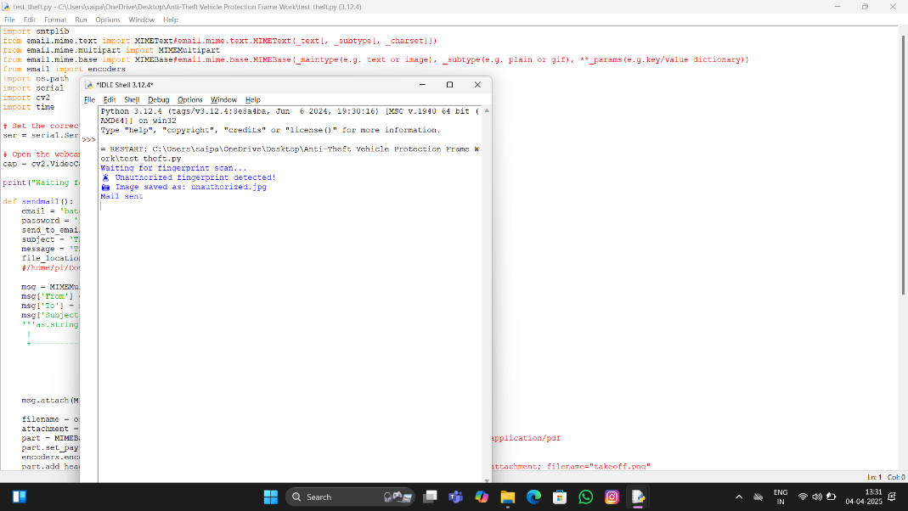

**Fig.12:** Photo Capturing & Email Sending

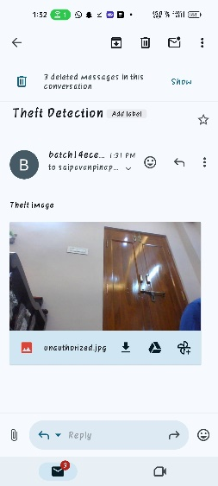  
**Fig.13:** Email Received of Theft Detection

**4.4. Vibration-Based Intrusion Alert**

Even without fingerprint input, if the SW-420 vibration sensor detects any suspicious vibrations—suggesting tampering or forced entry—the system enters alert mode. The GPS module (GY-NEO6MV2) is activated to obtain the current coordinates of the vehicle, and this location data is sent to the owner via the SIM800C GSM module in the form of an SMS. This ensures that movement or disturbance of the vehicle is immediately reported.

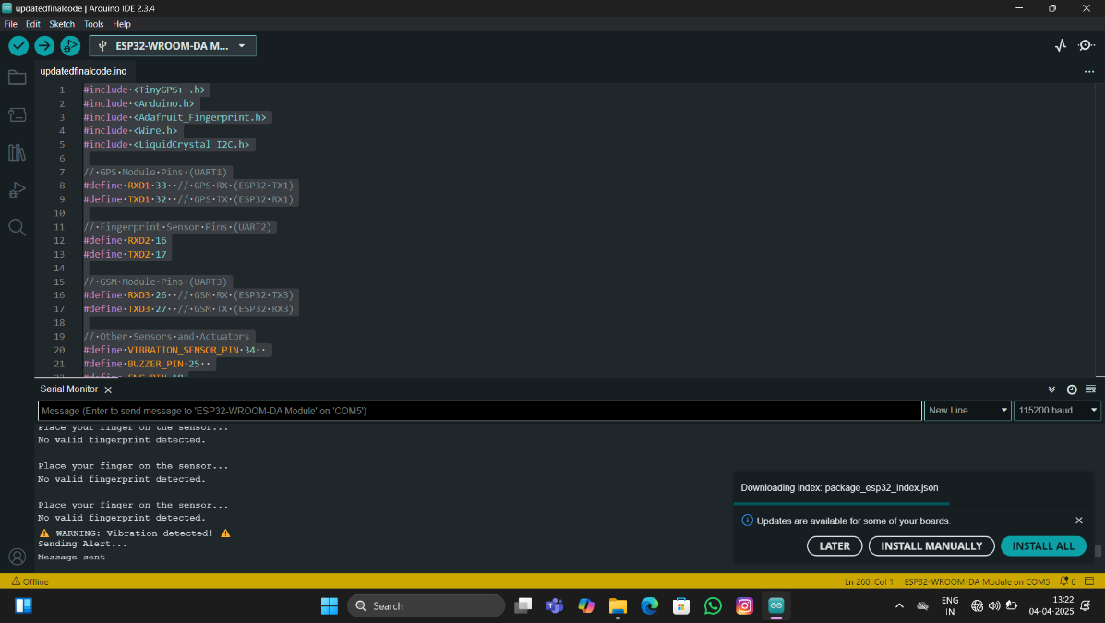  
**Fig.14:** Vibration Detected and SMS Alert & Location Sending through GSM

**4.5. Real-Time Alerts and Remote Control**

Following a vibration-based or unauthorized fingerprint alert, the system enables the vehicle owner to respond remotely. By sending predefined SMS commands to the GSM module, the owner can deactivate the motor, preventing the vehicle from being used. This offers a reliable control option, especially in low-connectivity regions.

**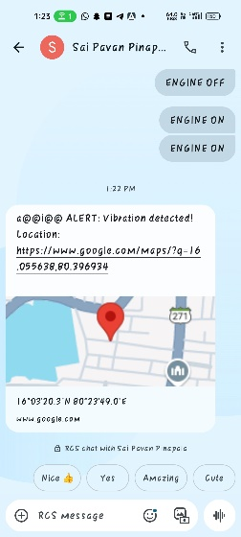  
Fig.15:** SMS Alert and Location Recieved

**4.6. Live Status Display and User Feedback**

Throughout the process, the I2C LCD continuously displays real-time updates including fingerprint authentication results, sensor activation alerts, and the status of GPS and GSM modules. This constant feedback allows the user to remain informed of the vehicle’s security status.

**5. Conclusion**

In this paper, this project presents a comprehensive and intelligent vehicle anti-theft system that effectively integrates embedded electronics, biometric authentication, real-time monitoring, and remote communication. By combining the ESP32 microcontroller with modules such as the R307S fingerprint sensor, SW-420 vibration sensor, SIM800C GSM, GY-NEO6MV2 GPS, and an I2C LCD, along with Python-powered laptop camera integration, the system provides multi-layered protection against unauthorized access. It not only deters theft through immediate alarms and physical deterrents like the mosquito module but also ensures real-time alerts and control via SMS and email notifications. This innovative framework demonstrates the practical application of IoT and embedded technologies in enhancing vehicle security and empowering users with smart, proactive control.

**6. Future Work**

While the current system offers robust protection through multi-sensor integration and real-time communication, future improvements could significantly enhance its functionality and scalability. Potential upgrades include integrating a dedicated external camera module with night vision capabilities for clearer intruder identification, using cloud-based storage for image and event data for better accessibility, and incorporating AI-based facial recognition for advanced authentication. Additionally, developing a mobile app for real-time system control, notifications, and GPS tracking could improve user experience and accessibility. Expanding the system to support voice alerts, automatic police notification, and CAN bus integration for direct interfacing with vehicle internals could make the framework even more comprehensive and suitable for commercial deployment.

**7. Acknowledgement**

We sincerely thank our guide, **Mr. K. Mallikarjuna Rao**, for his valuable support and guidance throughout the project. We are also grateful to our faculty and lab staff for their assistance and encouragement. Special thanks to our families and friends for their motivation. Lastly, we appreciate the teamwork and dedication of our group, which made this project a success.

**8. References**

1. Rana, S., Mewari, R., & Nautiyal, L. (2018). Anti-theft Security System for Vehicles. *International Journal of Engineering & Technology*, 7(4.12), 42-46.
2. Virmani, D., Agarwal, A., & Mahajan, D. (2021). Anti-Theft Alert System for Smart Vehicles. *International Journal of Engineering Applied Sciences and Technology*, 6(6), 330-335.
3. Suaysom, I., & Adsavakulchai, S. (2010). Remote Control of a Motor Vehicle and Theft Prevention. *International Journal of Advanced Research in Computer Science*, 1(1), 22-27.
4. Rana, S., Mewari, R., & Nautiyal, L. (2018). Anti-theft Security System for Vehicles. *International Journal of Engineering & Technology*, 7(4.12), 42-46.
5. Virmani, D., Agarwal, A., & Mahajan, D. (2021). Anti-Theft Alert System for Smart Vehicles. *International Journal of Engineering Applied Sciences and Technology*, 6(6), 330-335.
6. Manjunath, T.C. (2010). Remote Control of a Motor Vehicle and Theft Prevention. *International Journal of Advanced Research in Computer Science*, 1(1), 22-27.
7. Rana, S., Mewari, R., & Nautiyal, L. (2018). Anti-theft Security System for Vehicles. *International Journal of Engineering & Technology*, 7(4.12), 42-46.
8. Virmani, D., Agarwal, A., & Mahajan, D. (2021). Anti-Theft Alert System for Smart Vehicles. *International Journal of Engineering Applied Sciences and Technology*, 6(6), 330-335.
9. Suaysom, I., & Adsavakulchai, S. (2010). Remote Control of a Motor Vehicle and Theft Prevention. *International Journal of Advanced Research in Computer Science*, 1(1), 22-27.
10. Rana, S., Mewari, R., & Nautiyal, L. (2018). Anti-theft Security System for Vehicles. *International Journal of Engineering & Technology*, 7(4.12), 42-46.
11. Virmani, D., Agarwal, A., & Mahajan, D. (2021). Anti-Theft Alert System for Smart Vehicles. *International Journal of Engineering Applied Sciences and Technology*, 6(6), 330-335.
12. Manjunath, T.C. (2010). Remote Control of a Motor Vehicle and Theft Prevention. *International Journal of Advanced Research in Computer Science*, 1(1), 22-27.